**Assignment 11.1:**

1. Transfer data between Mysql and HDFS [Import and Export] using sqoop:

**Exporting Files from HDFS to Mysql using sqoop:**

**Step1:**

Create a new database in the MySQL instance

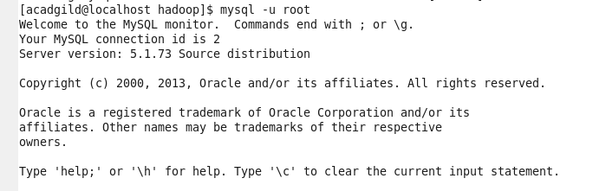

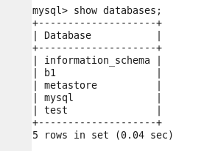





**Step2:**

Create a table named **emp**

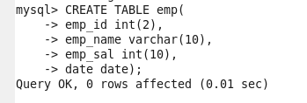

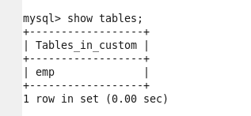



describe a table **emp**

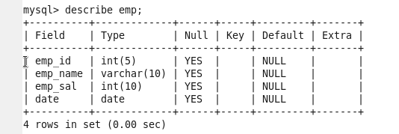

File inside HDFS must have same format as that of MySQL table, to enable the mapping of the data.

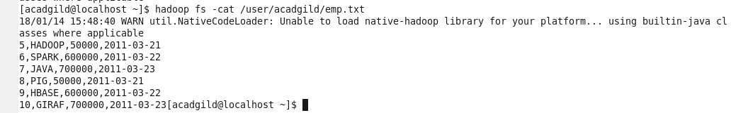

**Step3:**

Export the text file from HDFS to MySQL

